http://www.javatpoint.com/this-keyword

**Define-**

**Encapsulation- Encapsulation is the packing of data and functions into a single component. The features of encapsulation are supported using classes in most object-oriented programming languages, although other alternatives also exist.**

**this**.keyword- this is a reference to the current object — the object whose method or constructor is being called. You can refer to any member of the current object from within an instance method or a constructor by using this.

constructor chaining-

Calling another constructor in the same class from another constructor is called constructor chaining. By using this() we can call another constructor in the same class. Incase we want to call another constructor, this() should be the first line in the constructor. Below example shows code for constructor chaining. - See more at: http://www.java2novice.com/java_constructor_examples/constructor_chaining/#sthash.sd4G8fGN.dpuf

**Programming Assignments:**

**USE OBJECT ORIENTATED PROGRAM DESIGN TO SOLVE PROBLEM**

Task 1- Create a class BMI. (Body Mass Index)

BMI = 703*weight / height * height [[height squared]]

The BMI class should also return the person’s name using the program.

Create a method for calculating BMI and round BMI to 1 decimal place

Create a method for returning the BMI possibilities

Severe Thinness < 16

Moderate Thinness 16.1 – 17

Mild Thinness 17.1 – 18.5

Normal 18.6 – 26

Overweight 26.1 – 30

Obese Class I 30.1 – 35

Obese Class II 35.1 – 40

Obese Class III > 40.1

**Output:**

The BMI for John is 26.5 which is the Overwight Category.

or

The BMI for Susan is 17 which is in the Moderate Thiness Category

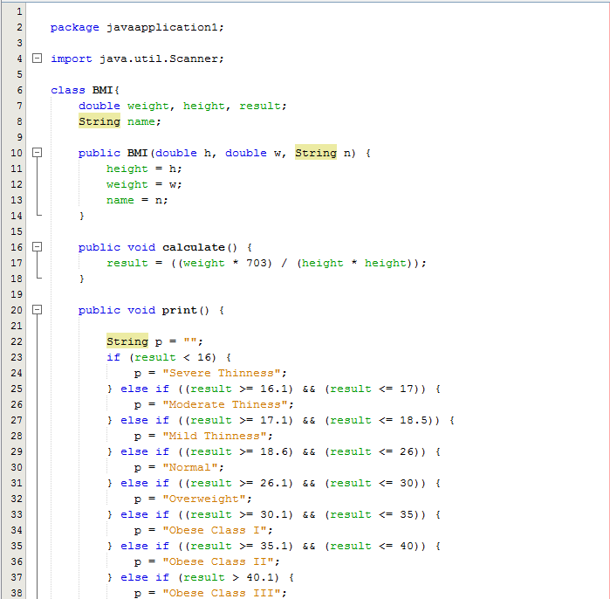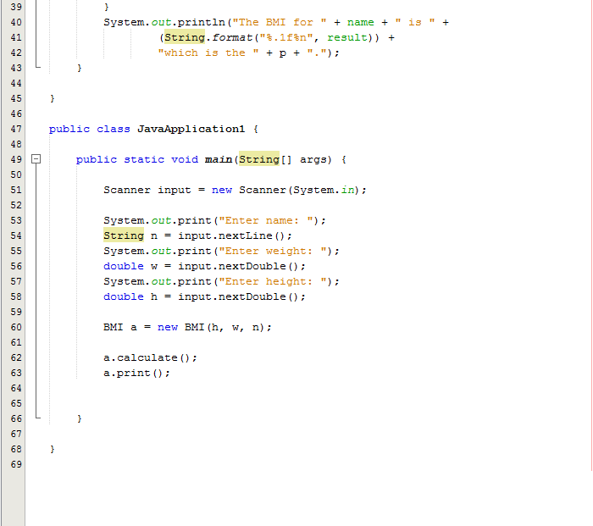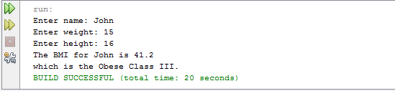

**USE OBJECT ORIENTATED PROGRAM DESIGN TO SOLVE PROBLEM**

Task 2- Create a class Course.

Create 1 course. Fill the course with female and male students.

Output the course name and the total number of students enrolled, number of women enrolled and the names of students enrolled in the course.

**Output:**

CIS36A contains 10 students, 6 Female Students, and 4 males students.

Mary Smith, Lisa Brown, Jill Scott, Bobby Jones, etc.

